Meeting Notes
Big dates
- Early June 6th SAT

Meeting Notes - next steps

Apr 3, 2026
Next Steps:
- Summarise / create the prediction performance plots (e.g. ROC, etc.)
  - Use the trained GNN to generate what India’s FUTURE (next year or next 3 years) product network would look like
- Research what the “right / recommended” approach is to generating the LLM export capabilities graph (LLM embedding space)
- Calculate the F1 score for the GNN Model and graphs.
Prediction methods in sequence / increasing order of sophistication
- RCA Persistence - predict based on current RCA value: if current RCA > 1, simply predict RCA > 1 (if first 3 years of the 5-year period RCA > 1 → predict RCA > 1)
- Product space density → apply KNN to classify whether the product RCA > 1
- KNN on LLM embedding space (target - do this together next session)
- Gradient-boosted classifier on tabular features
- Temporal bipartite GNN - ✅
- Temporal GNN + LLM capability layer

Jan 18, 2026

Next steps:
- Download and clean data

Instructions: Data Acquisition and Preparation for trade_data.csv
1. Source Data Access
- Repository: CEPII BACI Database (International Trade Database at the Product-Level).
- Access Method: Create a free account on the CEPII website.
- Required Files:
  - Trade Flows: Download the latest HS version (e.g., BACI_HS17_V202401.zip). If longitudinal consistency prior to 2012 is required, HS07 or HS92 versions may be substituted.
  - Metadata: Download the auxiliary files country_codes_V202401.csv and product_codes_HS17_V202401.csv (located on the same data page).
2. Data Transformation Protocol
Raw BACI data is provided as bilateral flows (Exporter $i$ $\to$ Importer $j$). The following transformations are required to produce the country-product matrix ($c, p$) needed for the GNN:
- Aggregation: Group raw records by Year (t), Exporter (i), and Product (k). Sum the Value (v) column to obtain total exports per product for each country.
- Unit Conversion: Multiply the aggregated value by 1,000 (BACI values are reported in thousands of USD).
- Identifier Mapping:
  - Map the numeric exporter code (i) to the ISO-3 character code (e.g., 840 $\to$ USA) using the country_codes metadata file.
  - Pad Product codes (k) with leading zeros to ensure a consistent 6-digit string format (e.g., 10101 $\to$ 010101).
- Filtering: Remove records where the country mapping is missing (e.g., obscure territories) or where product codes are not valid 6-digit HS strings.
3. Target Output Schema
The final file should be saved as trade_data.csv with the following columns:
Column | Type | Description
year | Integer | Year of observation (e.g., 2015)
country_code | String | ISO-3 country code (e.g., "IND")
product_code | String | 6-digit HS code (e.g., "854231")
export_value | Float | Total export value in USD

Jan 3, 2026
Ashwanth in competition ending on 8th of Feb

Next Steps:
- Read this blog on Comparative Advantage - https://www.economicshelp.org/trade2/comparative_advantage/
- Read the next paper on Product Space by Hidalgo - https://www.science.org/doi/10.1126/science.1144581
- Re-read the building blocks of economic complexity by Hidalgo - https://www.pnas.org/doi/10.1073/pnas.0900943106

Dec 12, 2025
Next Steps:
- Read Hidalgo’s https://www.pnas.org/doi/10.1073/pnas.0900943106
- Go through - William Ackman: Everything You Need to Know About Finance and Investing in Under an Hour | Big Think

Core Idea: trade and international finance
- Technique: Graph Neural Network

Idea #1: Exposure to foreign debt affects sovereign risk / currency movements?

Idea #2: Portfolio investment network analysis → are countries situated economically closer to “tariff hubs” exposed to greater risks?

Evaluating:
. Two sets of results
High income middle income and low income
Vol of export - top 20

Research Notes
Trade Complexity 2.0: Forecasting export diversification with a temporal country–product GNN + an LLM-derived capability graph, deployed as a public dashboard.

RQ: Can a temporal bipartite GNN trained on the global country–product export network predict which new products 0a country will gain comparative advantage in (RCA≥1) over the next 1–5 years better than classic Economic Complexity / Product Space baselines—and does adding an LLM-based product capability layer improve both predictive accuracy and interpretability/actionability?
Core hypotheses
- H1: A temporal bipartite GNN outperforms ECI/Product Space baselines because it learns higher-order network structure beyond hand-crafted proximity metrics. PNAS+1
- H2: Adding an LLM-derived “capability similarity” signal improves performance especially for rare/complex products and rapidly changing economies.
- H3: LLM + GNN explanations recover Product Space intuition (adjacent diversification) but with sharper, data-driven pathways. arXiv+1

Country set (for the dashboard narrative)
India (main story), Vietnam, Mexico, Indonesia (challengers) + China, Singapore, UAE (comparators/hubs).

Data (public + research-grade)
- Trade flows (HS6, annual): CEPII BACI (reconciled from Comtrade, designed for analysis; ~200 countries, 5k+ products). cepii.fr+1
  - Alternative/validation source: UN Comtrade / Comtrade+. comtrade.un.org+1
- HS product titles/labels (from the HS nomenclature used in BACI/Comtrade) as text input for the LLM layer. cepii.fr+1
- (Optional extension covariates) Tariffs (HS6 bilateral applied duties) via CEPII MAcMap-HS6 for “tariff uncertainty / rerouting” analysis layers in the dashboard. cepii.fr+1

Ablation study
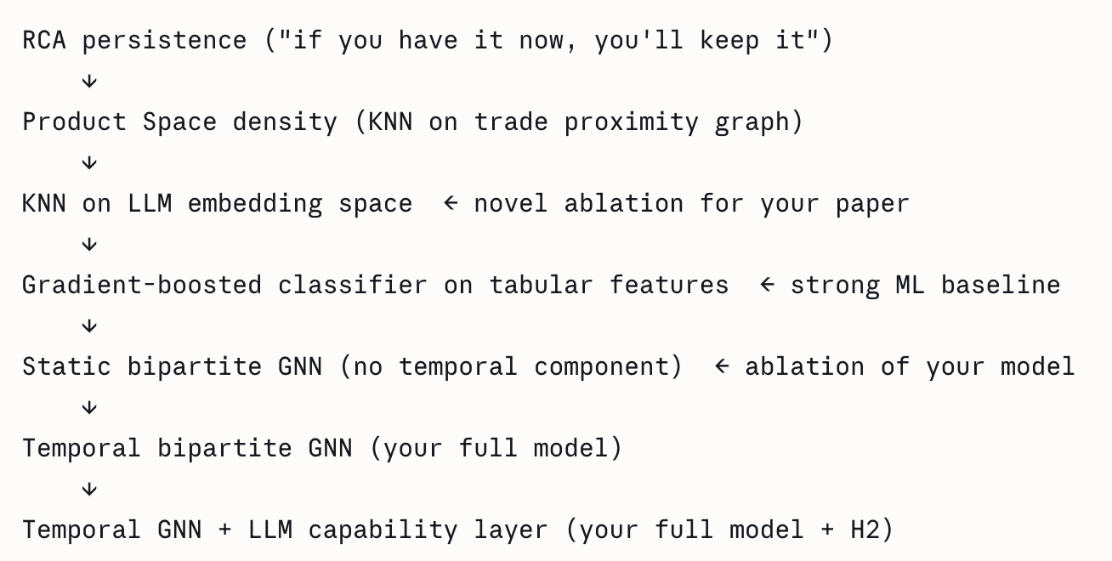
Next meeting discussion:
- Transport costs may outweigh any comparative advantage
- Increased specialisation may lead to diseconomies of scale
- Governments may restrict trade
- Comparative advantage measures static advantage but not any dynamic advantage for example in the future India could become good at producing books if it made the necessary investment

Questions and Doubts:
Questions and Doubts:

- Which year range to use for training? 2002-2023? But would it account to the tariffs impact for analysis?

Graph creation notes:
1. Create a export graph with india in the center and edges to it countries nodes with its weights
Use networkX python library for visualisation.
You can use a gif for timelapse

- Export/Import Netowrk
  - Size of each node should reflect the trade volume
  - Length of the edge, should be reflecting how far the country from india.

limitations of product space methods:

1. Current paradigm: Uses static snapshot, doesn't use past historic data
2. current methodology doesn't take into account the capabities needed for a country to produce a product.

limitation of currect GNN methodology:

1. Doesnt directly measure the capabilities of a country

Claude Code Audit

Mar 15, 2026

Part 1 — What Exactly Are We Predicting?
This confuses most students, so let's be precise.
RCA is measured at the country × product level, not industry level. Specifically at the HS6 (6-digit Harmonized System) product level. HS6 means something like "854231 — Electronic integrated circuits: processors and controllers." There are roughly 5,000 such product codes. RCA is NOT measured at the industry level (like "electronics" or "textiles") — that would be HS2 or HS4. HS6 is granular enough to be scientifically meaningful.
The exact prediction task is this: given country $c$'s entire export basket observed up to year $t$, predict a binary label for every product $p$ that $c$ does NOT currently export competitively: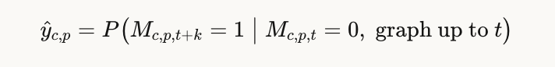
$$\hat{y}{c,p} = P\bigl(M{c,p,t+k} = 1 ;\big|; M_{c,p,t} = 0,; \text{graph up to } t\bigr)$$
So we are predicting new entries — the 0 → 1 transitions in the binary RCA matrix. Not "does India export semiconductors" (too coarse), but "does India export HS 854231 specifically." The graph structure gives the model context about which nearby products India already exports, and the LLM layer adds knowledge about what capabilities those products require.

Part 2 — Code Review of the Student's Repo
I can see the full file listing and two committed tensor artifacts, which together tell me a lot. Here is a structured audit:GitHub rate-limited the file-level reads, but the directory listing and the two committed artifacts (country_x_by_year.pt and country_features_enriched.csv) already tell a significant story. Here's the full breakdown.

What exactly we're predicting, and at what level
Let me show this visually first, then do the code audit.Now the full code audit. From the file listing and committed artifacts, here are all the issues, organized by severity:Now let me go through each issue in detail so the student can actually fix them:

🔴 Critical: step3_smoothing.py — temporal leakage
"Smoothing" RCA across years sounds reasonable (reduces noise from one-off export spikes) but is the most dangerous step in the pipeline. A 3-year rolling average computed as mean(t-1, t, t+1) uses the future year t+1 — which means the RCA value you feed the model at year t already contains information about year t+1. Your labels are based on t+1. You've just leaked the answer into the input. The only safe version is a trailing window: mean(t-2, t-1, t). The student needs to confirm the window parameter and whether min_periods is set.

🔴 Critical: step4_labels.py — labelling all 1s vs. only new 1s
This is the most common conceptual mistake. There are two possible label definitions:
- Wrong: label = M[t+k][c,p] — this labels all pairs where the country exports at t+k, including those it already exported at t. The "positive rate" will be ~10–15%, which seems OK but is scientifically wrong. The model will learn "countries keep exporting what they already export" — a trivial, useless result.
- Correct: label = (~M[t][c,p]) & M[t+k][c,p] — only 0→1 transitions. The positive rate drops to ~3–5%. Harder task, but that's the science.
The student must check this exact line in step4_labels.py.

🔴 Critical: step8_split.py — temporal vs. random split
If this uses sklearn.model_selection.train_test_split, it is wrong. That function randomly shuffles rplit assigns all years ≤ 2018 to train, 2019–2020 to validation, 2021+ to test. Nothing from future years ever enters training.
ows, which means a (India, chip, 2021) edge might appear in training while a (India, chip, 2018) edge appears in test. The model trains on the future to predict the past. The correct s

🔴 Critical: no product node features
The committed file country_x_by_year.pt stores country features. There is no product_x_by_year.pt or equivalent. In a bipartite GNN, both node types need feature vectors. If products are initialised as zero vectors or random noise, the GNN's product embeddings are meaningless — the model is essentially just doing matrix factorisation on the country side. The LLM embeddings (completely absent from the repo) were supposed to solve exactly this.

🟡 Serious: integrate_wdi_data.py is orphaned
This script exists outside the numbered pipeline (step1–step10). WDI data (GDP per capita, FDI inflows, etc.) can genuinely improve country features, but the country_features_enriched.csv file being committed as a static CSV raises questions: is it re-generated when the pipeline reruns? What year range does it cover? Does it include years in the test set (leakage)? The WDI integration should be step0_wdi.py that feeds cleanly into step5_features.py.

🟡 Serious: no baselines at all
The research question explicitly asks whether the GNN beats "ECI/Product Space baselines." There is no script in the repo that computes ECI, PCI, the proximity matrix φ, or density scores. Without these, you cannot answer your own research question. These are not optional extras — they are Table 1 of the paper.

🟡 Serious: no LLM embedding step
H2 — the key innovation — is completely absent from the pipeline. No sentence-transformer step, no product text file being used, no product_llm_embeddings.npy. The student has built a standard GNN but not the "GNN + LLM capability graph" that the paper is about.

🟠 Moderate: negative sampling ratio unknown
With ~3% positive rate in the label matrix, a naive training loop (one random negative per positive) still gives a 1:1 class ratio — fine. But if the student is treating all 0-cells in the matrix as negatives simultaneously (~97% of the ~1 million country-product pairs), the loss is overwhelmed by easy negatives and the model collapses to predicting everything as 0. Need neg_ratio=5 and random negative sampling per batch.

🟠 Moderate: binary files committed to git
country_mapping.pkl, country_x_by_year.pt, and the CSVs should be in .gitignore. They can't be reproduced by anyone who doesn't have trade_data.csv, and they'll break if the pipeline parameters change. The repo should contain only code plus a README.md explaining how to regenerate them.
, git re
The one-sentence summary for the student: the data pipeline has leakage in three places (smoothing, labels, split), the model is missing its core innovation (LLM product embeddings), and there are no baselines — so even if the GNN trains, there's nothing to compare it against and no paper.
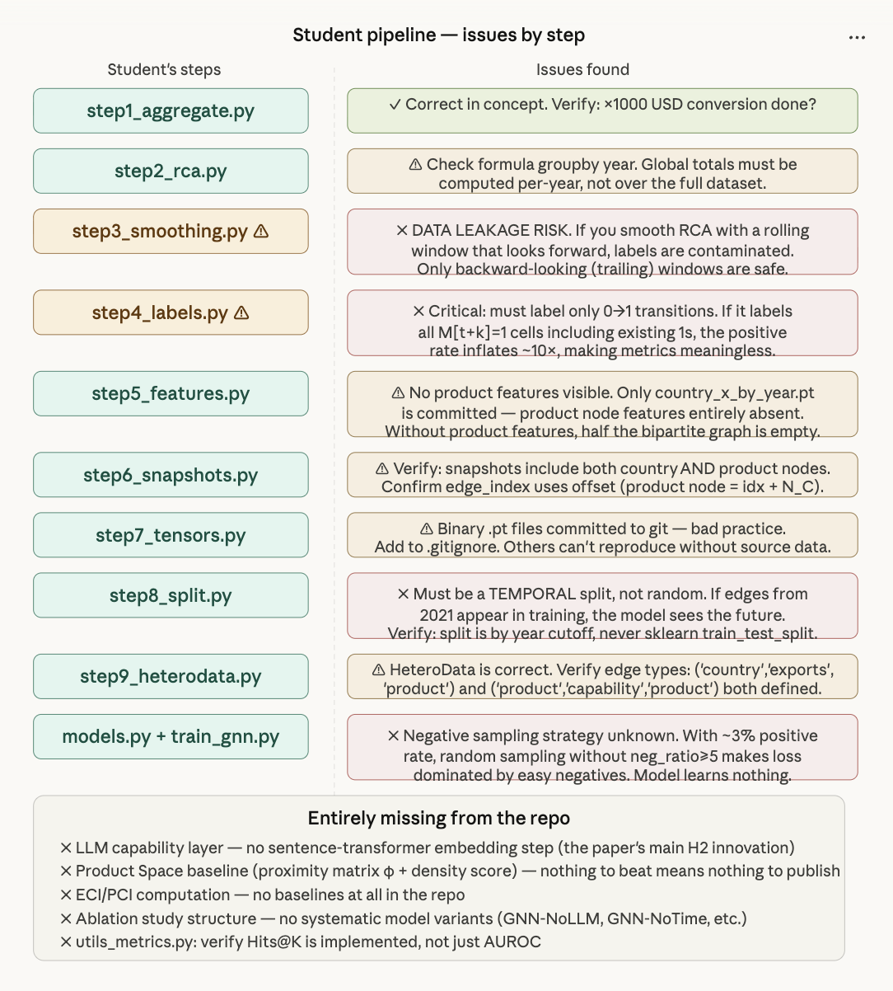

GNN Model:
GNN Model:

1. Country Node Features (Dim: 4)
These represent the economic state of the country in each year of the history.
Feature Name | Description | Rationale
log_export | Total export value (log-scaled) | Larger economies have more resources to diversify.
n_products | Count of products with RCA ≥ 1 | Measures the diversification/complexity of the country.
avg_rca | Average RCA across all products | Identifies the overall "strength" of the country's export basket.
max_rca | Maximum RCA value found | Identifies if a country has a world-leading specialization.

2. Product Node Features (Dim: 3)
These represent the nature of the product in the global market.
Feature Name | Description | Rationale
log_world_export | Total global trade value of this product | Larger markets are often more competitive or easier to enter.
ubiquity | Number of countries exporting this with RCA ≥ 1 | Measures how "hard" or "exclusive" a product is.
avg_rca | Global average RCA for this product | Measures the global average competitiveness of the product.

3. Graph Topology (Edges)
This is the most "powerful" part of the GNN's input:
Feature Name | Description | Rationale
edge_index | The bipartite map of which countries export which products | Captures the Product Space. The GNN uses this to see which countries are "neighbors" in terms of what they produce.

4. Temporal Context
- 5-Year Window: The model doesn't just see these values once; it sees a sequence of them for the last 5 years. This allows the GNN to detect if a country is trending upward in a specific category before it actually hits the RCA ≥ 1 mark.

1. Country Node Features (Dim: 11)
Your country node now has 11 total features: 4 from trade (BACI) and 7 from development (WDI).
Feature Category | Feature Name | Description | Rationale
Trade (RCA) | log_export | Total export value ($) | Capacity for large-scale production.
 | n_products | Count of RCA ≥ 1 products | Current economic diversification.
 | avg_rca | Average RCA | Overall comparative advantage strength.
 | max_rca | Maximum RCA value | Peak specialization intensity.
Development (WDI) | gdp_pc | GDP per capita (Log) | General wealth and purchasing power.
 | population | Total population (Log) | Size of the domestic labor market.
 | manufacturing_va | Manufacturing value added (% of GDP) | Existing industrial capacity.
 | capital_formation | Gross capital formation (% of GDP) | Level of investment in the economy.
 | tertiary_enroll_ | Tertiary school enrollment (%) | Human capital and high-skill labor.
 | internet_users | % of pop using internet | Infrastructure and digital readiness.
 | fdi_inflows | Net FDI inflows (% of GDP) | Global integration and investment appeal.

2. Product Node Features (Dim: 3)
Products use global trade metrics to define their "difficulty" and "popularity".
Feature Name | Description | Rationale
log_world_export | Total global trade value | Market size and liquidity.
ubiquity | # of countries exporting this | Product complexity (Low ubiquity = High complexity).
avg_rca | Global average RCA | Standard competitiveness baseline.

3. Graph Topology
- Bipartite Edges: The model "sees" the existing trade links (RCA ≥ 1) between countries and products over a 5-year sequence.

Tab 6
Equal Evaluation Metrics

